HOW DO I ACCESS MY MATERIALS?

Q: I am receiving a No Access Error, how do I correct this?
A: The first thing that must be done when you receive a message pertaining to no longer having access is to click on the "Lost Password" option at the login screen. I realize this sounds silly considering you know your password, but it seems to be the fix for content issues at this time. Once completed, you should be able to access the site without issue. If not, please email our Director of Customer Success at happiness@thegrownetwork.com with more information as to what you are encountering. We will do our best to get you back into the system as soon as possible.

Q: I have clicked the Lost Password and still do not have access. What do I do?
A: Please try to clear your cache (see instructions below) and/or try an alternate browser.

Q: How do I clear my cache with Firefox?
A: 1. From the History menu, select Clear Recent History.
- If the menu bar is hidden, press Alt to make it visible.
- From the Time range to clear: drop-down menu, select the desired range; to clear your entire cache, select Everything.
- Next to "Details", click the down arrow to choose which elements of the history to clear; to clear your entire cache, select all items.
- Click Clear Now.
- Exit/quit all browser windows and re-open the browser.

Q: How do I clear my cache with Google Chrome?
A: 1. In the browser bar, enter: chrome://settings/clearBrowserData
- Select the following:
- Browsing history
- Download history
- Cookies and other site and plug-in data
- Cached images and files
- From the Obliterate the following items from: drop-down menu, you can choose the period of time for which you want to clear cached information. To clear your entire cache, select the beginning of time.
- Click Clear browsing data.
- Exit/quit all browser windows and re-open the browser.

Q: How do I clear my cache with Microsoft Edge?
A: 1. In the top right, click the Hub icon (looks like three horizontal lines).
- Click the History icon, and then select Clear all history.
- Select Browsing history, then Cookies and saved website data, and then Cached data and files. Click Clear.
- After the "All Clear!" message appears, exit/quit all browser windows and re-open the browser.

Q: How do I clear my cache with Internet Explorer?
A: At this time, we do not recommend the use of Internet Explorer on our website. Please consider the download of an additional browser for optimal use of our site.

Q: How do I clear my cache with Safari?
A: 1. Open your Settings app.
- Tap Safari.
- Tap Clear History and Website Data and confirm.
- Exit/quit all browser windows and re-open the browser.

Q: How do I clear my cache with Android?
A: 1. Go to Settings and choose Apps or Application Manager.
- Swipe to the All tab.
- In the list of installed apps, find and tap your web browser. Tap Clear Data and then Clear Cache.
- Exit/quit all browser windows and re-open the browser.

Q: How do I clear my cache with Chrome for Android?
A: 1. Touch Chrome menu > Settings.
- Touch (Advanced) Privacy.
- Touch Clear browsing data.
- Exit/quit all browser windows and re-open the browser.

Q. How do I change my password?
A: 1. Once you have logged into the system, click on The Lab
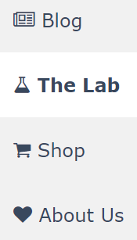

2. Click on Edit Profile under My Account
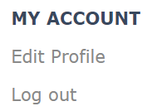

3. Enter Your Information Under Change Your Password for This Site
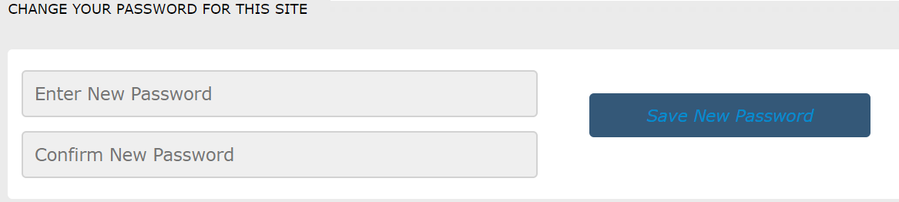

Q. I still can’t access my materials after trying the above steps. Help!!
A: If you still continue to run into an issue logging into our site, please email our Director of Customer Success at happiness@thegrownetwork.org for additional assistance.

